**DFD :**

Admin

Client

Registration Registration Successful

Manage Orders

Place Order

Product Details

Payment Product Details

Receipts Payments

Receipts

1st Level DFD :

**Client**

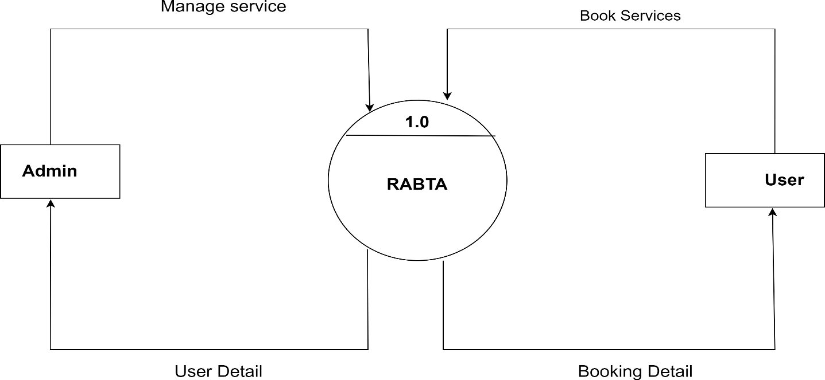

Booking Registration

1.0